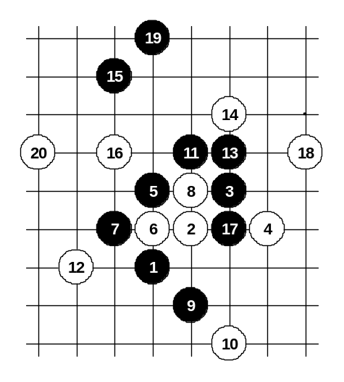
The variants of G: and H: are identical in many cases. But there are lots of positions where the different distance from the board edge influences the result of the variant. Frankly, black has much more problems here.

H

Diagram i1-29

Compared to the diagram i1-7, here the black attack fails due to the closeness of the board edge.
Therefore, similar attack is not good under the circumstances.

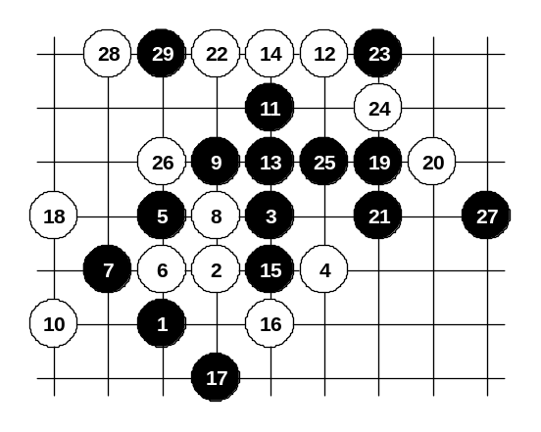

Diagram i1-30
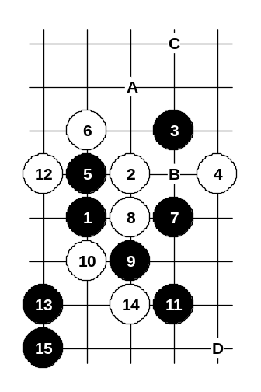
Beautiful attack that gave black victory in diagram i1-10, it does not work here. The closeness of the right edge ruins the similar attack. It is hard to say if black can still win here (in lower area) or not, but it is surely complicated now.

Diagram i1-31

Another 5th move. Compared to the diagram i1-18, black cannot attack in same area due to the board edge’s influence. Black develops attack in opposite side with move 13-13 here. The outcome is very good for black. If 14-A then 15-B, 17-C, 19-15.
If 12-D then 13-13. Any other 10th move doesn’t offer a serious resistance. Compared to the diagram i1-17, black attacks exactly in the same way.
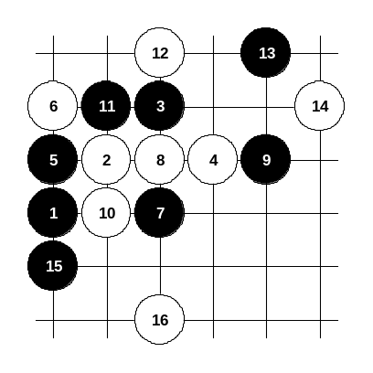

Diagram i1-32
The development in the style of diagram i1-19 doesn’t work here because there is not enough space on the right side. Black has to play 13-13 and 15-15 now. After the 16th move black has many possibilities to continue developing on the left side, however, white possible counter-attack near the 16th stone area must be taken into consideration.

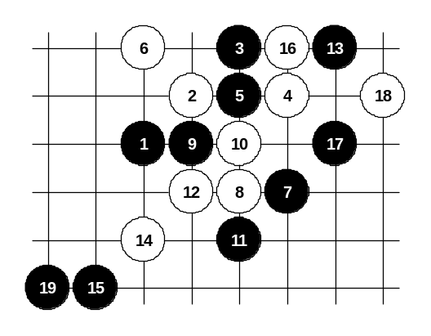
The third 5th move. Compared to the diagram i1-21, the black attack is even stronger now. By the 19th move black has sure win.

Diagram i1-33
If 14-16 then 15-14.

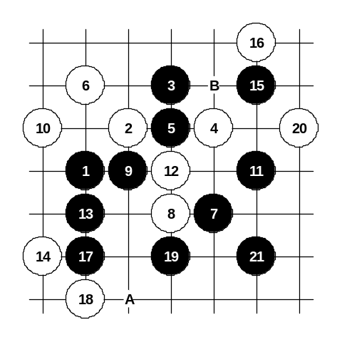

Diagram i1-34

Gambling variant from the diagram i1-22 needs different ending because of the edge problem here. From move 13-13 black begins straight winning attack.
If 20-A then 21-21. If 16-B then 17-17, 19-19, 21-21.

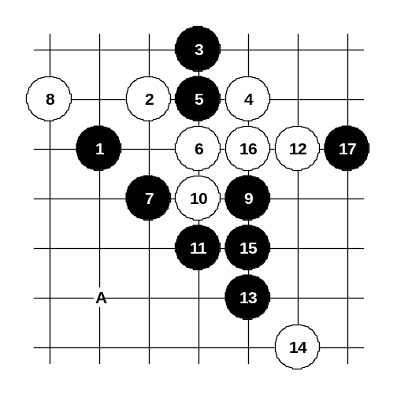

Diagram i1-35

Here the black may try to use similar ideas as in diagram i1-27, but here it might be a little bit harder because of the influence of the right edge. Another solution is to play carefully 15-A and avoid conflicts with edge problem.

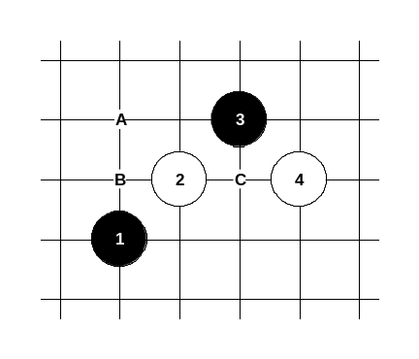

Diagram i1-36

Conclusion about that 4th move: The closeness of the board edge influences this pattern so that we can consider 5-A as problematic move, whereas 5-B and 5-C are still very good for black. Perhaps in the future there will be found solutions for 5-A, too.

I
This is the most traditional 4th move in i1 opening. In case of other 4th moves, black can keep the advantage, but after 4-4 most of the variants end with white advantage.
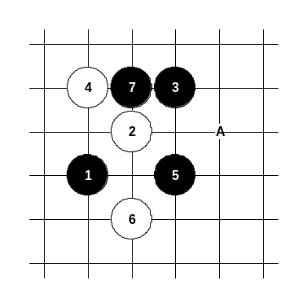

Diagram i1-37
This is the main 5th move. Here the black is very strong, therefore white usually does not let black play this move.
Almost all the variants of this 5th move lead to the variants of 4-6 or 4-A. After 6-6 the position becomes identical with the diagrams i1-16 ~ i1-19.
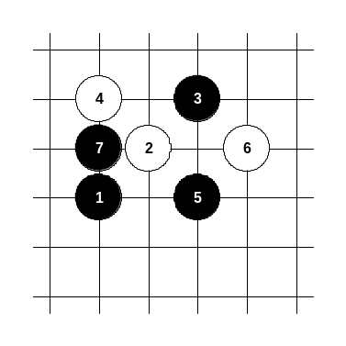

Diagram i1-38
Another 6th move. White makes an attempt to use the board edge’s influence.
However, black can play here as shown in diagrams i1-31 ~ i1-32.

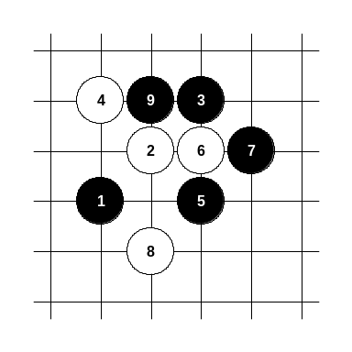

Diagram i1-39
Another 6th move. After 7-7 white has only one possible 8th move (8-8) that does not lose immediately.
After 9-9 the position becomes identical with diagram i1-18.
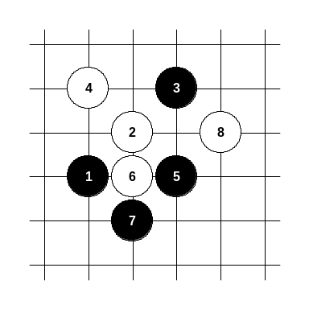

Diagram i1-40

After rotation of the 6th move the position becomes identical with diagram i1-31.

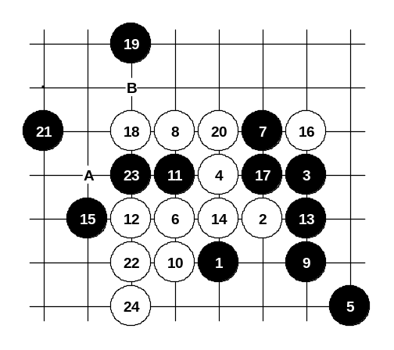
The main 5th move did not bring any problems for black, but finding good alternative 5th move is not easy. The structure of stones 2 and 4 does not let black organize the connections well enough.

Diagram i1-41
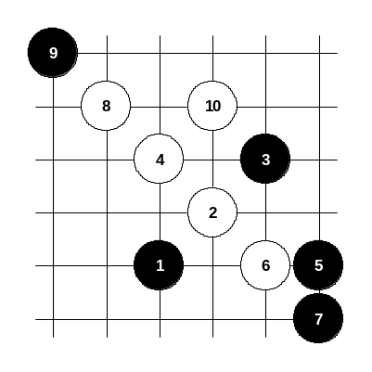
This 5th move is an attempt to use the “leap” style, similar to diagrams i1-20 ~ i1-23, but here the white activity goes out of black’s control and white wins. If 21-A then white has VCF (Victory by Continuous Fours) starting with 22-B.

Diagram i1-42
Another 5th move. It ends up with white’s immediate win, too.
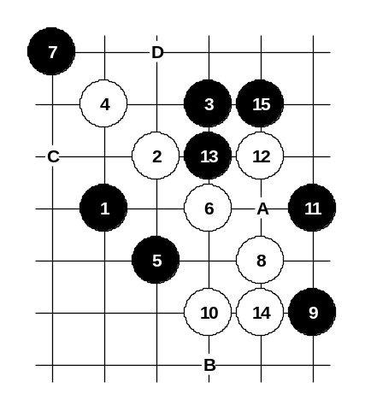

Diagram i1-43
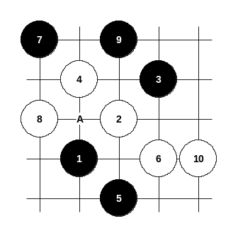
Another 5th move. Considering the pattern’s symmetry, there are four similar 5th moves: 5-5, 5-C, 5-12, 5-D. Since the white’s 6th move (6-6) is the only possible continuation, so after 6-6 the move 5-5 equals to 5-C and 5-12 equals to 5-D, whereas 5-5 and 5-12 are not exactly the same considering the closeness of the board edge. On the diagram i1-46 you can see whether the board edge influences the variants 5-5 and 5-12 or not. After 7-7 white has a dilemma – to develop to C-point or to 10-point. Not that the difference between those points is the location of 3-stone. On this diagram, black chooses attack through the 10-point according to the old Japanese theory. In that theory black played 15-A and 16-B, but after 15-15 there seem to be problems about continuation of white attack.

Diagram i1-44

As the white attack has problems in previous diagram, therefore white changed attacking plan – move 8-8 is more effective. But it is still early to announce this variant to be 100% white win because several 11th moves offer a good resistance and finding white win in game without home analysis might be complicated. The reason is that there is not much space on the right side. However, white still has quite big potential to find winning attack here, therefore we can consider such 5th move almost as losing move. If 9-A then 10-10.
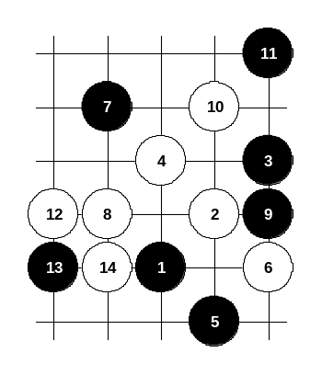

Diagram i1-45

Another 9th move does not help either, white win is quite simple here.

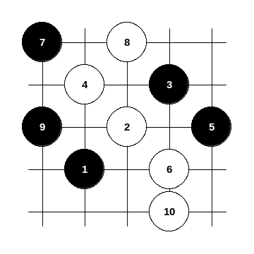

Diagram i1-46

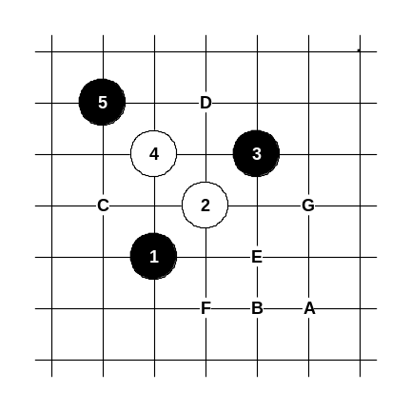
Symmetrical 5th move changes the direction of the white attack. Now white has even more space for the attack, therefore white has no difficulties to win here.

Diagram i1-47
Finally, this 5th move is the only reasonable alternative to 5-C. In case of optimal play of black and white, the outcome is quite equal, perhaps white has a minimal advantage.
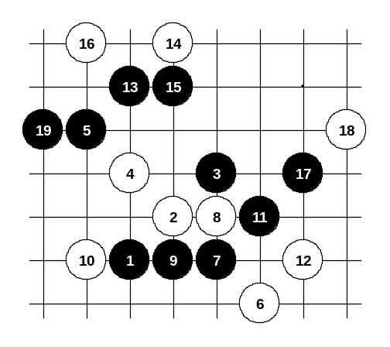
White has several choices for 6th move: 6-A, 6-B, 6-C (6-D), 6-E and 6-F (6-G), whereas 6-A and 6-B are the weakest and 6-F (6-G) is the strongest move.

Diagram i1-48
The gambling 6th move tries to lead the game to previous variants shown on diagrams i1-43 ~ i1-46. Black’s 7-7 is the only way to ruin that attempt. Besides, 7-7 is very strong – black can develop winning attack without big problems.
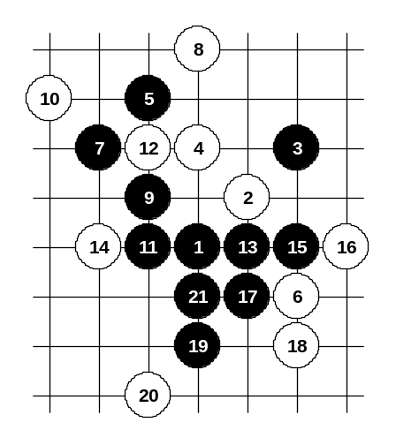

Diagram i1-49

Another gambling 6th move. The best black moves are 7-7 and 7-8. Black is very powerful on diagonal lines.

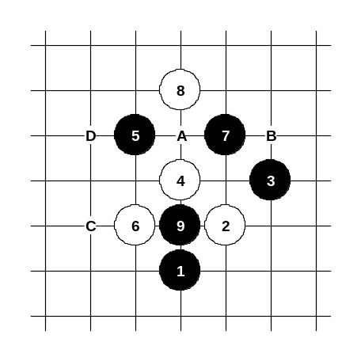
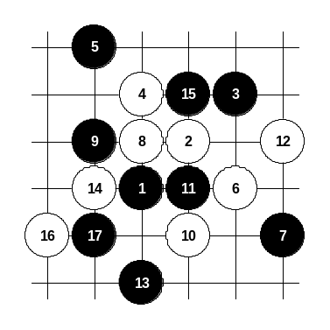
This 6th move is better than previous two 6th moves. Black does not win, but after the 9th move black has very good positional advantage. Free lines and sufficient space are good conditions for black’s attack here. Move 9-A is not good because of 10-B, 11-C, 12-D. Move 6-7 has a minor difference considering board edge’s closeness, but since black is developing in positional style, so black can always develop towards are with more space.

Diagram i1-50

Diagram i1-51

This 6th move is already a serious move. In the old times the games with such 6th move were extremely popular.. Black doesn’t have choices for 7th move. Move 7-7 is necessary. If 7-10 then look at the diagrams i1-43 ~ i1-46. Move 8-8 does not seem to be strong at the first look but in fact it contains lots of traps and unexpected developments. Move 9-9 – one of the choices. Move 11-11 is the only possible defense. The outcome of the variant is a little bit complex – white has the initiative but if white attacks carelessly then black may get the advantage on the other side.
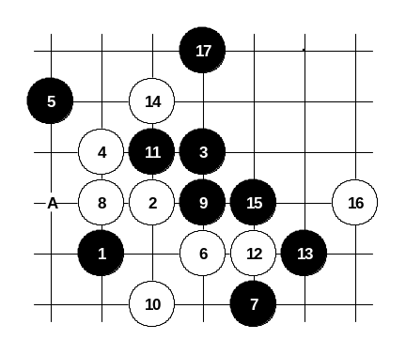

Diagram i1-52

This 9th move is better than 9-A. With move 11-11 black is taking over the initiative step by step.
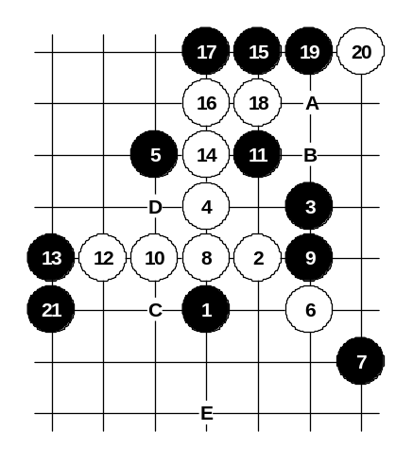

Diagram i1-53

An old Japanese variant. White gives pressure on forbidden point 16 (3x3) but black has a beautiful move 15-15 that saves black from loss and even gives satisfying position for black. Move 21-21 is an active defense. Those who favor peaceful style may try 21-A, 22-B, 23-C but that is not as good as 21-21.
Move 19-D is also possible.
If 11-12 then white wins: 12-11, 13-A, 14-E.

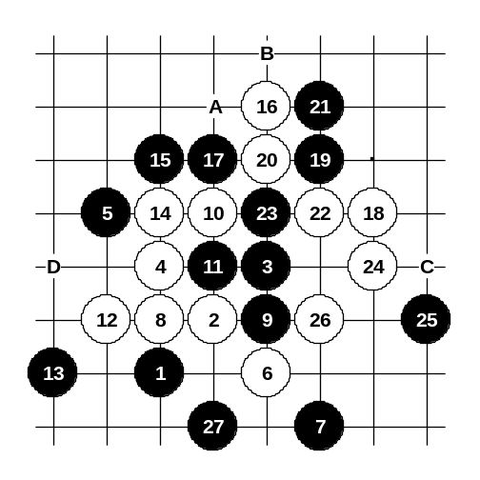
Another 10th move. The development with move 16-16 is very interesting. Such 17th move (17-17) is better than 17-A because in this way black has good potential to have an attack on the left and lower side in the future. If 18-22 then 19-18.

Diagram i1-54
If 18-19 then 19-A, 20-B, 21-21, 22-18, 23-C (… 20-D, 21-18).
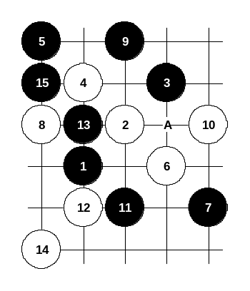

Diagram i1-55

Another 8th move. Beautiful 15th move creates very promising position for black. Move 11-A is also possible. If 10-13 then look the diagram i1-53.

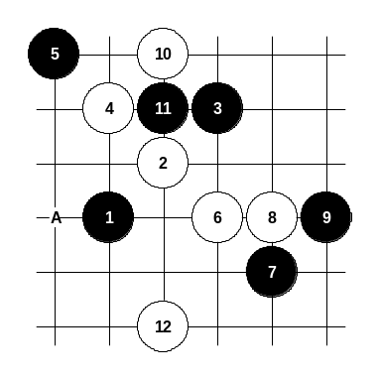
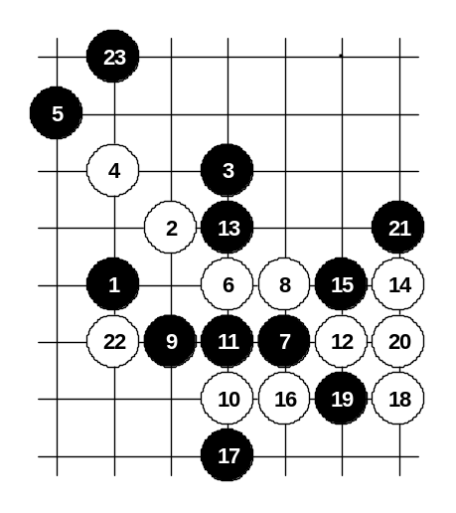
The last choice of 8th move. On this diagram black plays a weak 9th move and white gets powerful attack. The idea of 12-12 is to prepare a 3x3 trap at point A.

Diagram i1-56

Diagram i1-57

This 9th move is very interesting. Black gives up the initiative immediately but it is all part of the plan – black provokes white to attack on the right side, but the space there is not big enough.
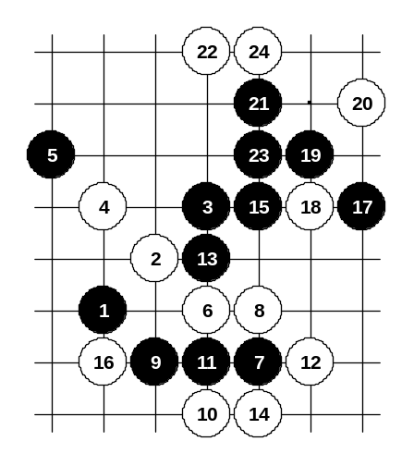

Diagram i1-58

This diagram proves the weakness of this 9th move. White does not follow black’s provocation and plays carefully 14-14. Black’s only chance is to attack, but by the 24th move it fails.

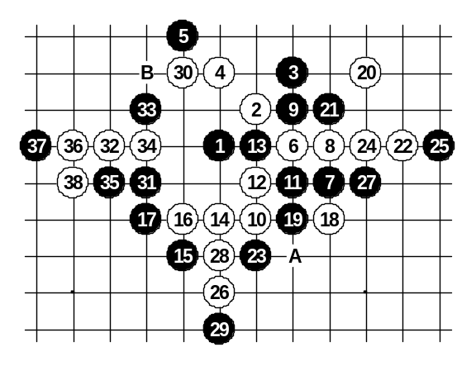
This is the main 9th move in this variant. Starting from move 12, white chooses the tactics of filling up all the important key points all over the board the outcome is very equal. If 27-28 then 28-A, 29-27, 30-30, 31-B, 32-33. White cannot play 26-35 because of black’s winning power in both lower and upper side after 27-28, 28-A, 29-27.

Diagram i1-59
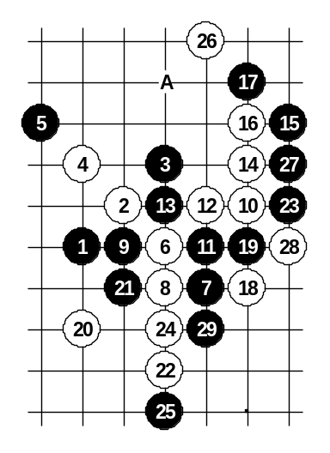

Diagram i1-60
Rotated 8th move enables white have useful 26th stone. White has better position here than on the previous diagram.
If 17-19 then 18-A.

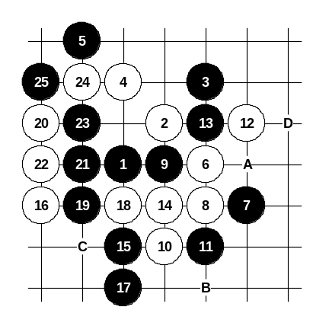

Another 10th move. It is active, but black can defend with careful moves. The outcome is satisfying for black.
It is also possible 11-A, 12-11, 13-B, 14-15, 15-C, 16-12, 17-14, 18-13, 19-D.

Diagram i1-61

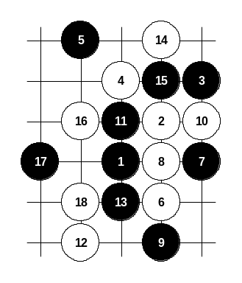

Diagram i1-62

This 6th move is the most widely used white development in i1 opening. It is also quite dangerous move – there is only one possible 7th move (7-8) after which black does not lose. The 7th move on the current diagram lets white have an easy win.

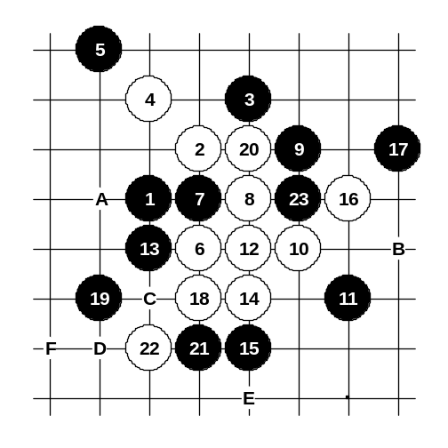
After correct 7th move (7-7) white has practically only two possible continuations – 8-8 and 8-A. Move 8-8 is active and contains lots of traps, but actually, if black defends correctly then white position becomes really weak. Therefore, serious players seldom use this 8th move.

Diagram i1-63
Move 9-9 is probably the best 9th move. Moves 11, 13, 15, 17 on the diagram are all forced – if black plays any of them elsewhere then white wins. If 21-22 then white wins: 22-B, 24-21, 26-C and black cannot avoid the forbidden 3x3 at point D. If 18-C then 19-19, 20-20, 21-18, 22-A, 23-E (…if 20-F then 21-21).
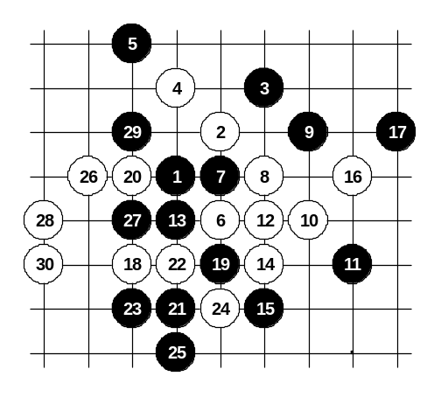

Diagram i1-64

Another 18th move. Black development with 19, 21, 23, 25 raise lots of questions since after the 30th move it is not easy to say whether black wins or loses.

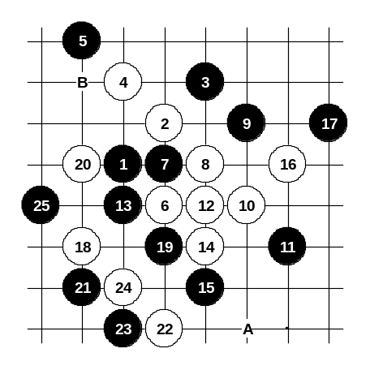

Diagram i1-65
This 21st move is more careful. Black does not let white’s activity go out of control. As a result, black gets good position without gambling.
If 22-23, 24-24 then 25-22 (black’s idea is to neutralize white activity while keeping tempo and after that continue development in upper area). If 22-25 then 23-23 and black wins. If 22-24 then 23-22. If 20-A then 21-B.
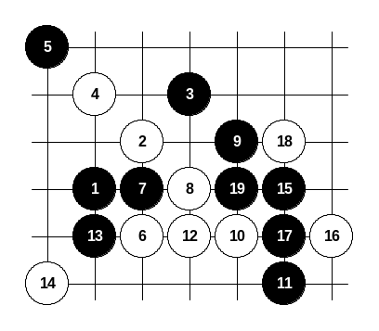
Here white tries to avoid further straight attack from move 14, but this style is very unsuccessful. Black moves 15, 17 and 19 take the white structure’s under black’s control, and as a result, black can continue developing positionally without fear of white’s counter-attack.

Diagram i1-66
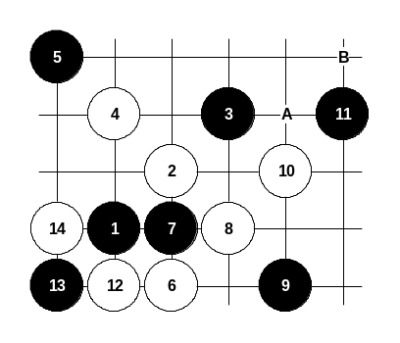

Diagram i1-67
Another 9th move. The outcome is very good for white. Move 12-12 is made in order to control black’s possible counter-attack through A and B.
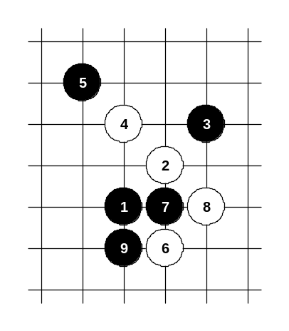
Conclusion: 9-9 is much worse than 9-10.

Diagram i1-68

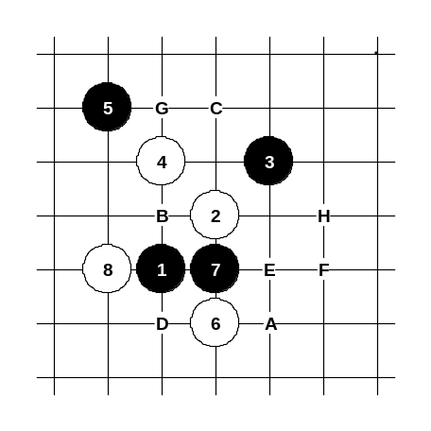
One more 9th move. Until now there is still no solid conclusion about it. Almost every possible continuation leads to gambling style, and it is not clear who will get benefit from this, black or white.

Diagram i1-69

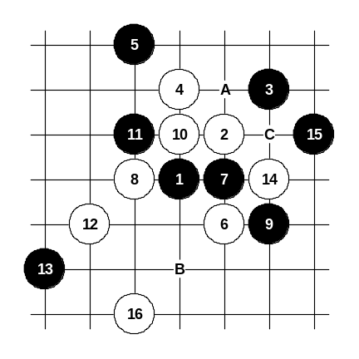
This is the most common 8th move. Black has a variety of different 9th moves, but the theory proves white advantage in case of any 9th move. In the following diagrams the 9th moves A, B, C, D, E, F, G and H are discussed.

The first 9th move. From move 12-12 white continuously keeps the advantage. If 13-A then 14-B, 15-14, 16-C.

Diagram i1-70

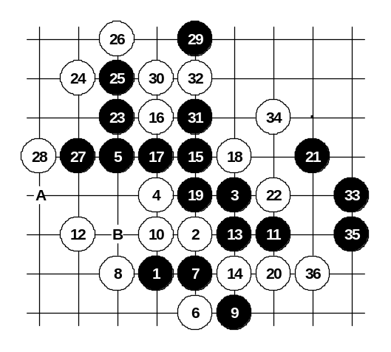
The 11th move is very interesting. White cannot continue passively because of black’s domination over right side’s space, therefore 12-12 is played. The following black attack is very beautiful, however, white will defend by the 26th move.

Diagram i1-71
If 21-29 then 22-A or 22-30.
If 10-14 then 11-11, 12-15, 13-B and the outcome is quite equal.

